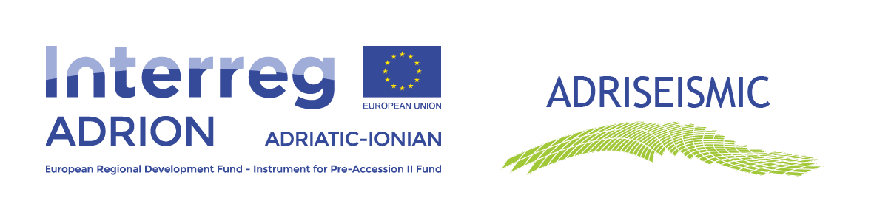

Invitation for participation
in the 1st online local workshop for New approaches for seismic improvement and renovation of Adriatic and Ionian historic urban centres in the context of the Interreg ADRION programme.

The Municipality of Gjirokaster
Invites you to participate to the 1st local Workshop that is carried out in the context of the European project ADRISEISMIC.

1st Local Workshop Ι Thursday 17-12-2020 Ι 09:30 – 12:30

The participation to the Workshop is free & the sessions will be carried out online using Webex platform.

Log in Here!

Contact Information: Filippidis Pavlos / email: p.filippidis@lp.gr / Tel.:210-3800750

The project ADRISEISMIC is funded by ERDF & IPA II Fund

